**Millipedes and desert beetles.**

**Please continue your examination of locomotion in arthropods.**

**Millipedes**

**Observe locomotion in the millipede. How much of the body moves as a unit when moving forward? When turning? What type of tracks would be left by the moving millipede, if fossilized? Are they impressions of appendages on or body segments dragged through the sand?**

**d. Which of the following tracks would they most resemble?**

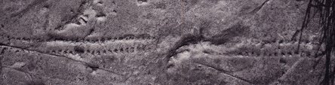Millipede track one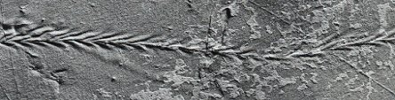Millipede track two

**Draw as best you can in Word or use your smart phone to “record” leg movement.**

Microsoft word instructions: Use insert a shape (the one highlighted below is a good one to use).



The size of any shape can be modified. Use blue circles to modify size, yellow to modify angle and green to modify orientation.



Once you have a basic shape, copy and paste a number of strokes to indicate “foot” movement.

See example below.

You can also do the same in preview by choosing blank page and then using a small oval or line to indicate “steps” used by the millipede or simply draw leg movement on a blank sheet of paper and give to your instructor to scan before the next lab.

**_____________________________________________________________________**

**INSECTS**

**True insects:**

**Insects are the most successful land group.**

**Compare the tagmatization found in an insect to that of the millipede and the various crustaceans you have worked with this week**. Can you distinguish three major sections? Do not worry about names on the diagram.

**You are to observe "walking" in an insect. Which legs move together? What is the distributed foot as it moves over an even surfaces or obstacles? Compare its movements to that of the millipede.**

**As our model we will use the desert darkling beetle.**

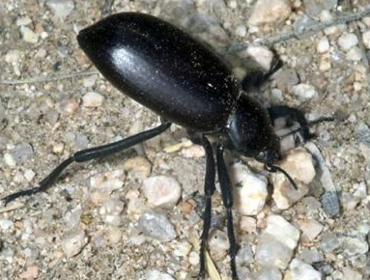

These flightless beetles are often seen trudging across trails and over sandy terrain. If bothered, the beetle does a headstand, signaling that it's ready to squirt a noxious substance onto an assailant. The spray is foul to the nose, and isn't dangerous to people. These species although related to those found in flour lead a very different life style and use their appendages differently. We may also have those that live in flour and so you can compare the structure and use of “legs” in the different types of beetle.

**A diagram of tagmata in a beetle.**

